THE IMPOSSIBLE DREAM

“No dreamer is ever too small; no dream is ever too big.” – Anonymous

Let’s take you through an unforgettable and most inspiring of moments that took place in the history of world football in 2016. Majority of the people in the world may have never heard the name before but what unfolded in the season of 2016 in the world of football, no one would ever forget it. Leicester City Football Club, also known as the Foxes is a professional football club based in England, now known as the Champions of England as they wrote their name in the history books by winning the Barclays Premier league Title in 2015-2016, in the most inspiring tales ever in the history of the sport and the world.

Let’s dig a little deep in how they fought the elite clubs of England and managed to pull off the greatest sporting upset ever with their unflinching self-belief, their overwhelming determination, putting in hours of hard work, blood and sweat to become the CHAMPIONS:

The story starts in 2008–09: 

It was Leicester's first ever season outside the top two levels of English football. the appointment of Nigel Pearson as the manager of the football club sparked a rebuilding of the club that would culminate in the fastest rise to the peak of the English football league system. Leicester returned to the Championship league at the first attempt, finishing as champions of League One after a 2–0 win at Southend United, with two games in hand.

2009–2010 season:

Leicester's revival under Pearson continued, as the club finished fifth and reached the Championship play-offs in their first season back in the second tier. Though coming from 2–0 down on aggregate, away to Cardiff City, to briefly lead 3–2, they eventually lost to a penalty shoot-out in the play-off semi-final.

2010-2011 season:

On 1 October 2010, after a poor start that saw Leicester bottom of the Championship with only one win out of the first 9 league games. They were unable to get promotion back to the premier league as they finished 10th.

2011-2012 season:

Leicester were viewed as one of the favorites for promotion in the 2011–12 season, but on 24 October 2011, following an inconsistent start with the Foxes winning just 5 out of their first 13 games, they finished 9th in that season.

2012-2013 season:

The Foxes could only muster a 6th-place finish in the 2012–2013 season, ensuring Leicester City were in the Championship play offs. Leicester lost the playoff semifinal 3–2 on aggregate to Watford.

2013-2014 season:

In 2014, Leicester's march up the league system hit a breakthrough. Their 2–1 win over Sheffield Wednesday, combined with losses by Queens Park Rangers and Derby County, allowed Leicester City to clinch a promotion to the Premier League after a 10-year absence. Later that month, a win at Bolton saw Leicester become the champions of the 2013–14 Football League Championship – the seventh time they had been champions of England's second tier.

2014-2015 season (Return to Premier League):

During the 2014–15 season, a dismal run of form saw the team slip to the bottom of the league table with only 19 points from 29 games. By 3 April 2015 they were 7 points adrift from safety. This could have brought a sudden end to Leicester's seven-year rise, but seven wins from their final nine league games meant that the Foxes finished the season in 14th place with 41 points. Their upturn in results was described as one of the Premier League's greatest ever escapes from relegation. They also became only the third team in Premier League history to survive after being bottom at Christmas and no team with fewer than 20 points from 29 games had previously stayed up.

2015-2016 season(Premier League champions): 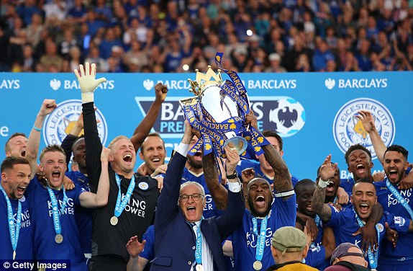

Leicester City appointed Claudio Ranieri as their new manager for the new 2015–16 Premier League season. Under Ranieri, Leicester won the Premier League on 2 May 2016, after Tottenham Hotspur failed to secure a win against Chelsea after only drawing the match 2–2.This completed the fastest seven-year rise to the title

As a person/Student, we all should remember that we all have to start from zero, work our way up to create a life that we aspire to live , to make our dreams a reality we have to work hard, show dedication to our work, never lose heart because no matter who you are, you will commit mistakes but you need to learn from them , you will have to go through failures but don’t lose hope, you will go through your share of problems and heartbreaks but no matter what never be ungrateful towards life, life is a good thing but it can be too damn short, so go do the things that you want to do, achieve your goals. Most of all never lose faith and never stop believing, good things will happen, it will always be worth it in the end.

As for Leicester the scale of the surprise attracted global attention for the club and the city of Leicester. It had been a hell of a ride. The team fought against all odds, when people were expecting them to buckle under the pressure and thinking that they were punching above their weight, they held their nerves, fought as a team, and got on with their work, had hope and self-belief to make their own destiny and in the end, were the CHAMPIONS of the league deservedly. So, pursue your dreams, no matter what and always remember:

Hope is a good thing, maybe the best of things, and no good thing ever dies.

~Stephen King

REFERENCES: <https://en.wikipedia.org/wiki/Leicester_City_F.C.>

Submitted by: ASHISH SONI

M.C.A (SEM-3)